**Name : احمد صلاح محمدي محمود**

**B.N: 70**

**Date : 30-5-2020**

**Topic:** **programming languages**

**Github link : https://ahmed-salah111.github.io/ece001/**

**Github page :**

**Application brief :**

**The quality of the computer system depends on the software packages that run it, and the software manages computer resources and components And software is the intellectual or software molecular of the computer A word program means a set of commands and instructions written in one of the programming languages, arranged according to a specific sequence performed by the computer The software includes all software used on the computer** **A programming language is a set of words and symbols that the programmer adheres to and is translated into a language the computer understands it is(0,1).**

**Examples of some languages:-**

**(Cobol –v . basic – Fortran - Pascal- A d A).**

**Computer programmer is the one who program and develop computer programming** **The programmer may be specialized in one of the programming areas, or it may program different types of software. The programmer can be considered a software engineer, software developer, or software analyst.**

**1-Screen shots:**

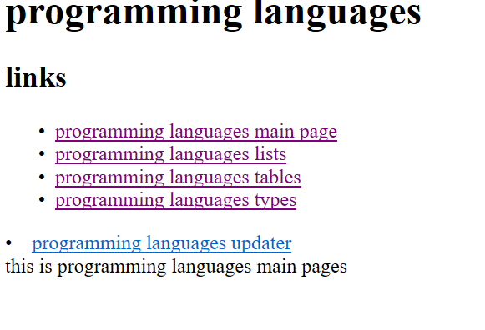

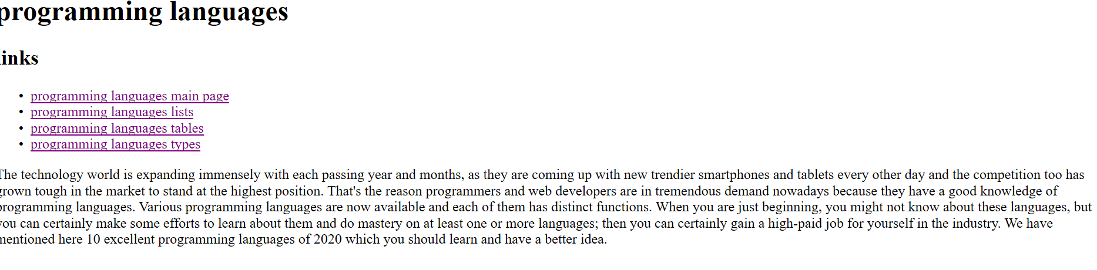

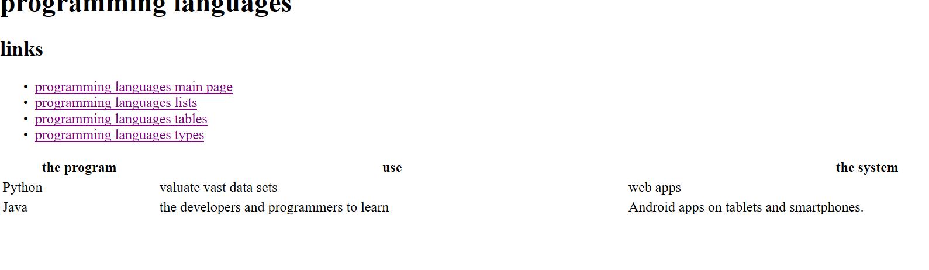

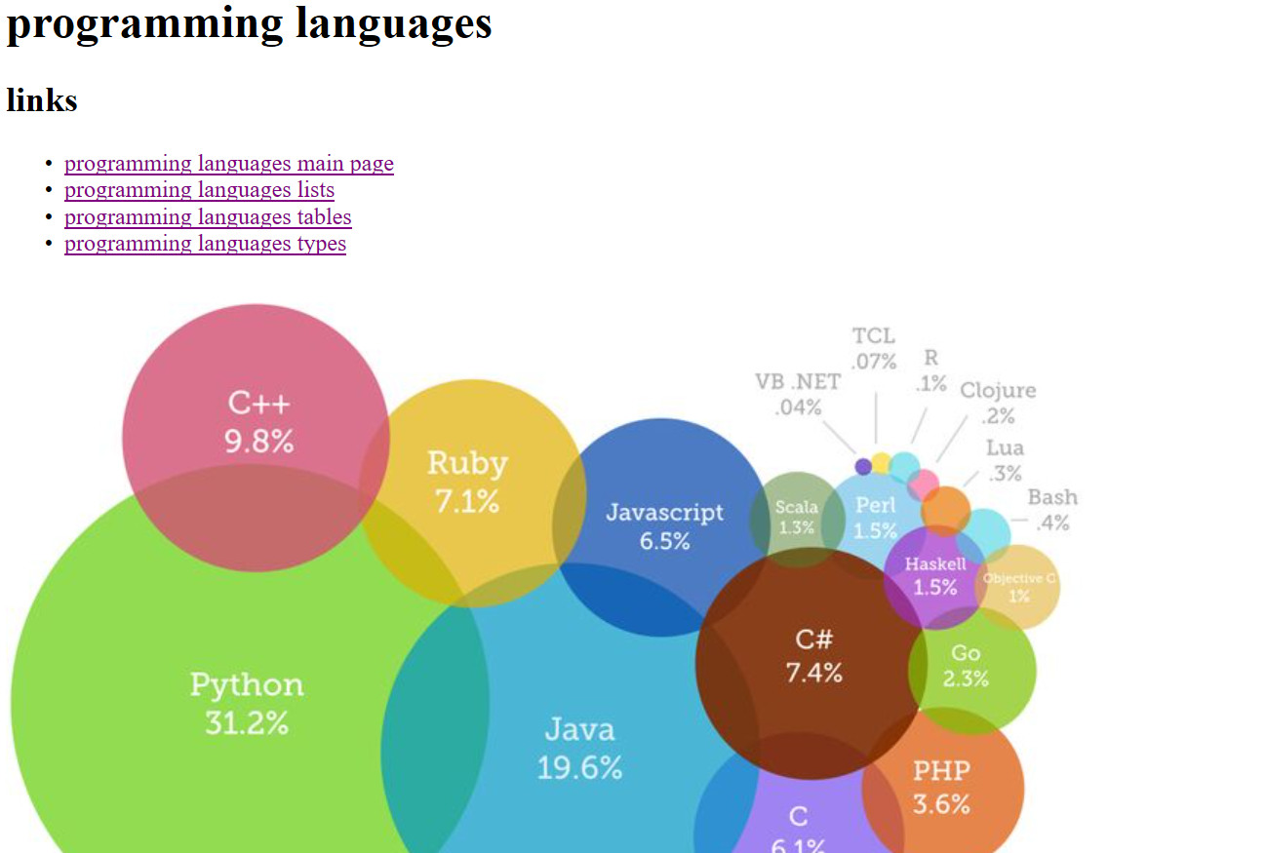

**2-sources codes:-** 